About Seaweed and What & Where We Do

About Seaweed

Seaweed cultivation, as a diversification activity in mariculture, has tremendous potential

all along the Indian coast. Seaweeds are rich in vitamins and minerals and are consumed

as food in various parts of the world and used for the production of phytochemicals, viz.,

agar, carrageenan and alginate, which are widely employed as gelling, stabilizing and

thickening agents in several industries of food, confectionery, pharmaceutical, dairy,

textile, paper, paint, etc.

Seaweeds such as Gracilaria edulis, Hypnea musciformis, Kappaphycus alvarezii,Enteromorpha flexuosa and Acanthophora spicifera can be successfully cultivated in long-line ropes and nets by vegetative propagation method.This activity has a potential to provide income and employment to about 200,000 families.

OBJECTIVES

To provide alternate livelihood to fisherwomen / Women SHG Groupfamilies in the

Coastal districts at least 150+ familes

To create avenues for additional income to Coastal fishers/ fisher women.

Production of seaweed which has manifold industrial benefits.

Out of approximately 700 species of marine algae found in both intertidal and deep sea waters of the Indian Coast. Nearly 60 sps are commercially important. Sea weed industry in India is mainly a cottage industry and is based only on natural stock of Agar yielding red sea weeds and Algin yielding brown sea weeds.

Design below link la undali

https://www.theseaweedcompany.com/our-approach

What We Do

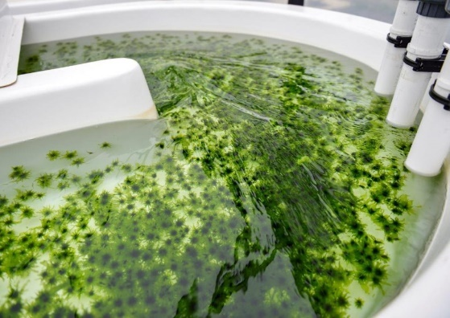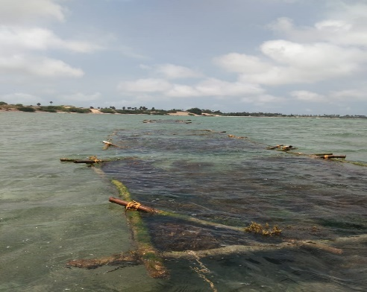

Land based farming sea-based farming

Seaweeds

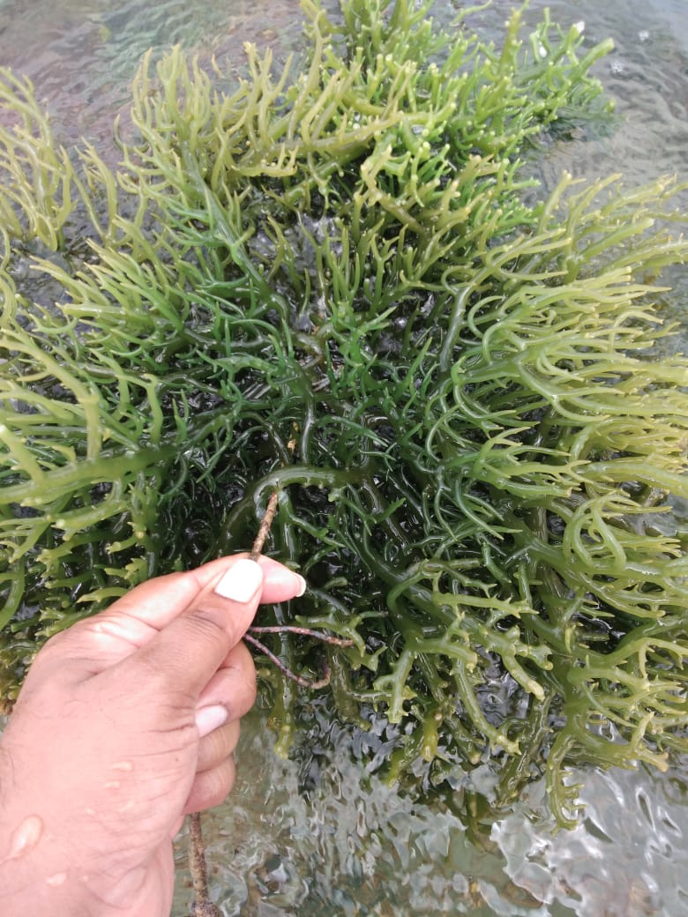

Kappa

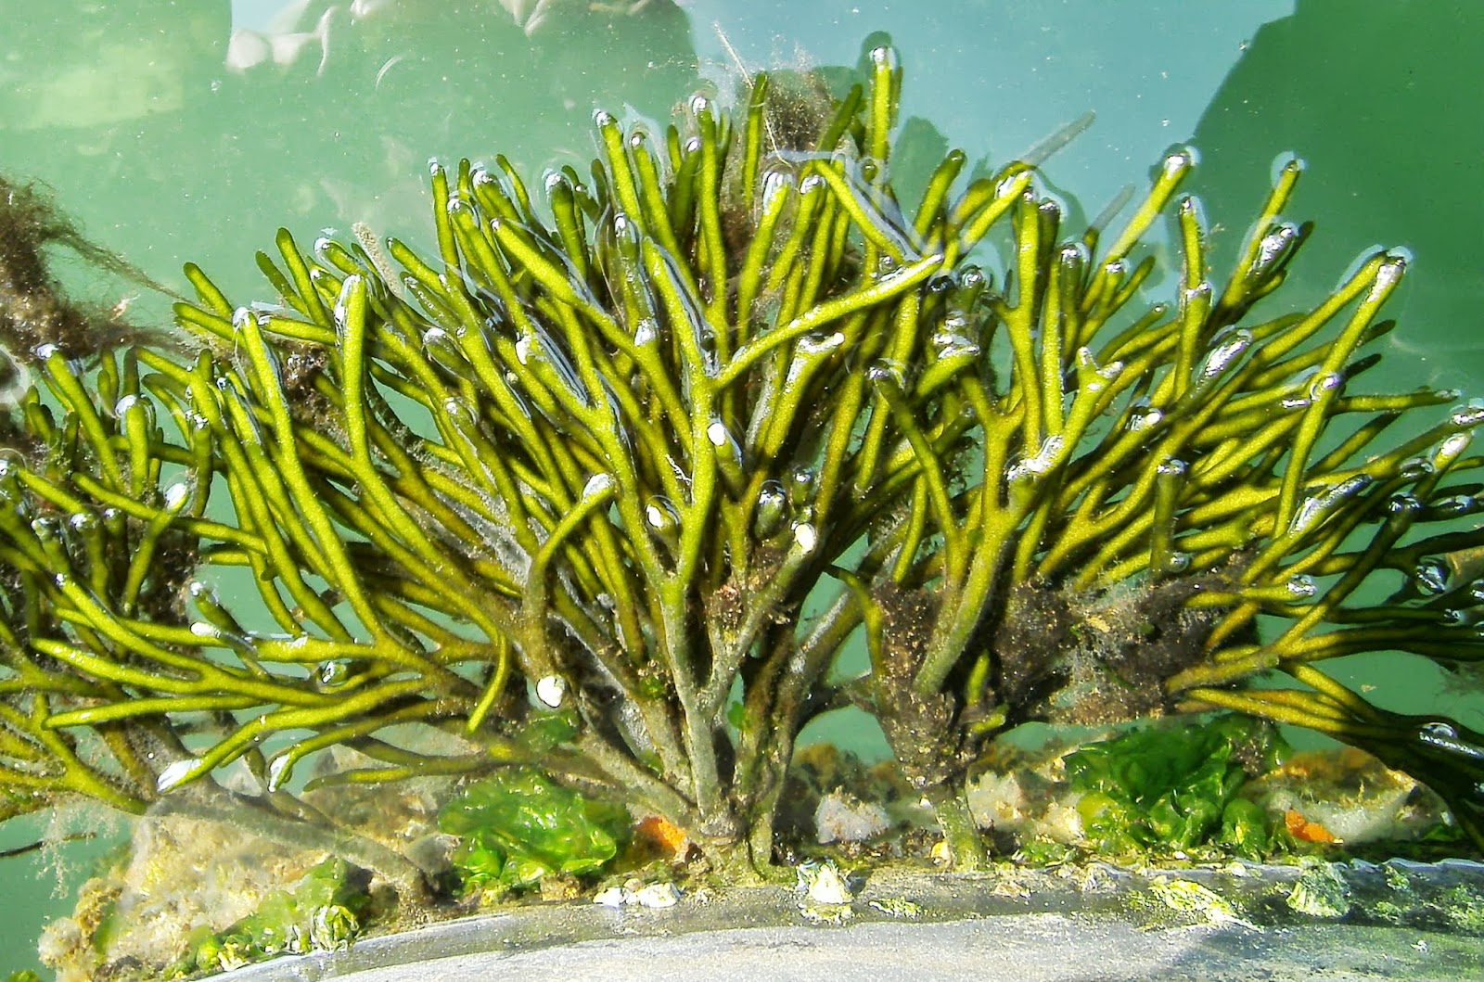

Codium

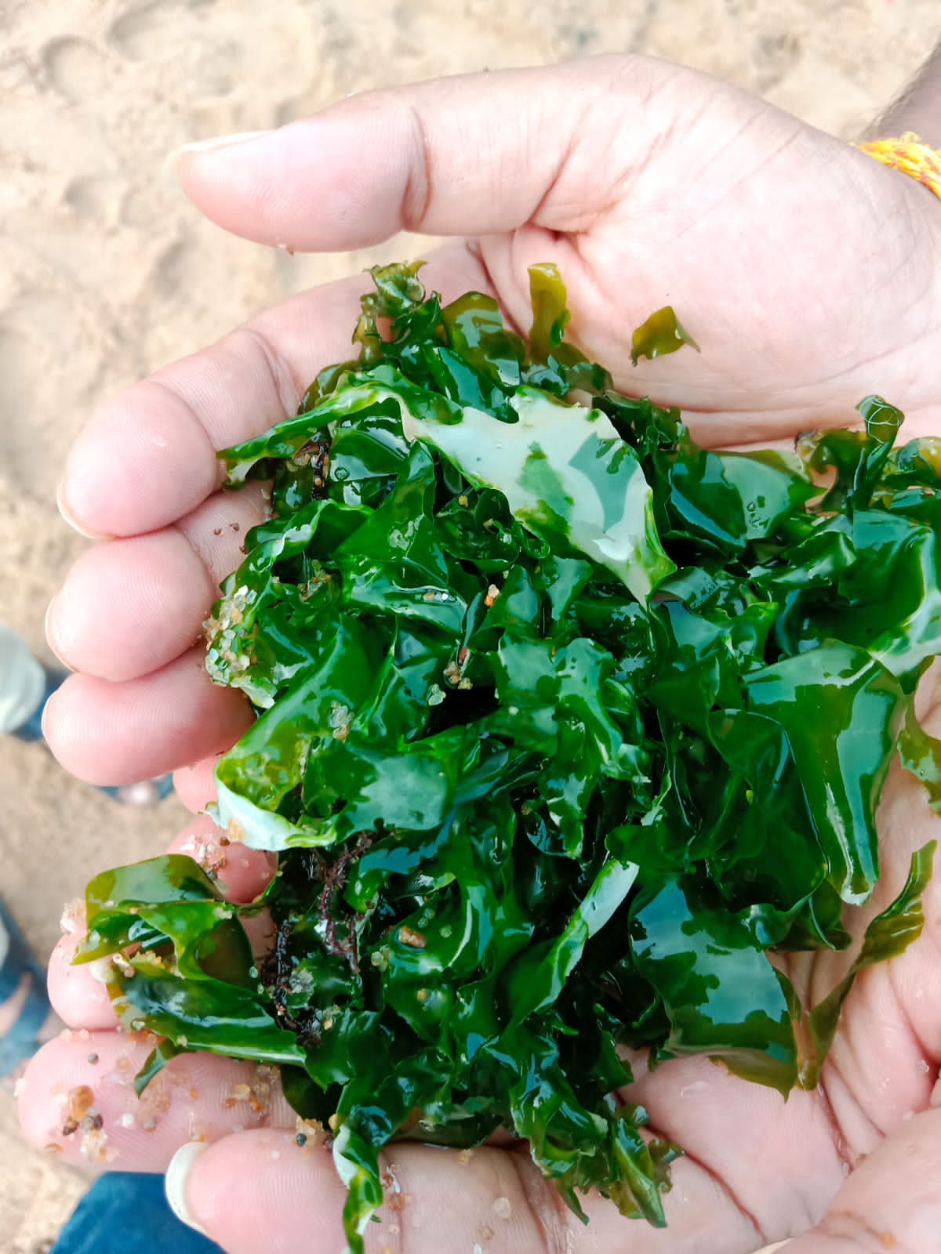

Ulva

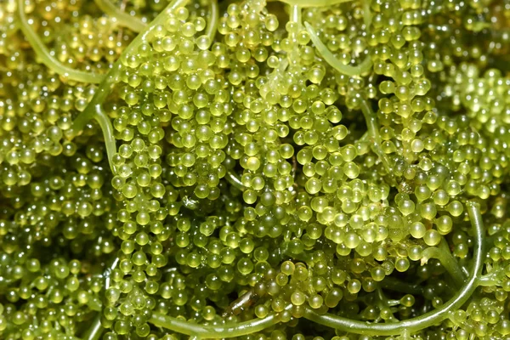

Seagrapes

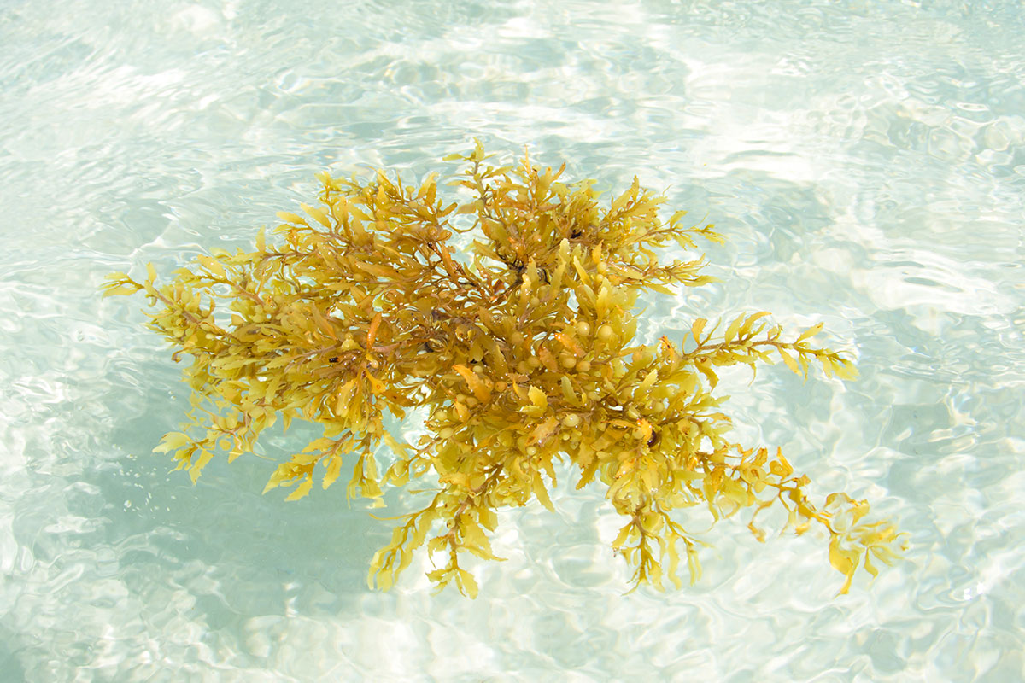

Sargassum

Where We Do

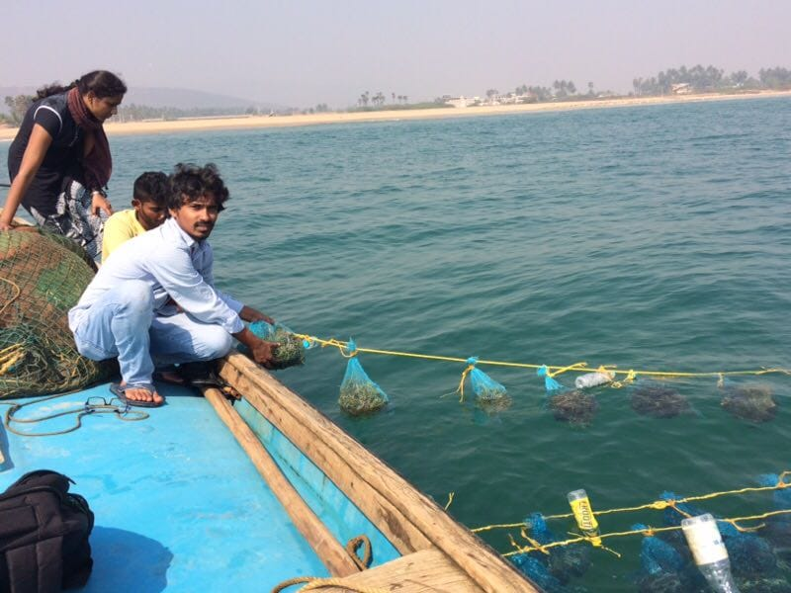

Vishakapatanam

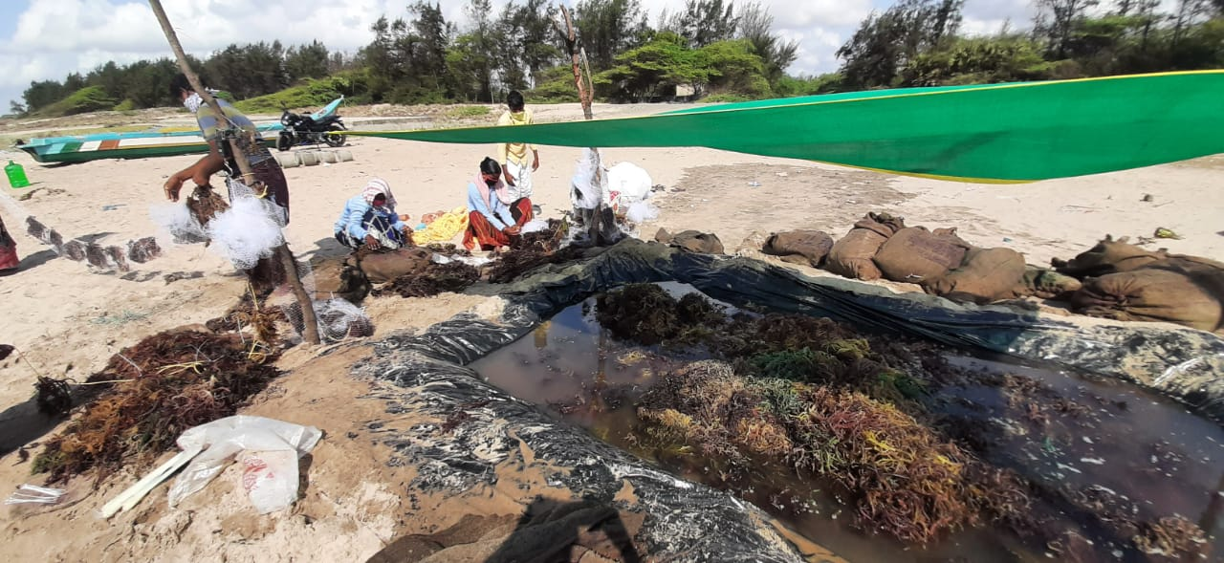

Ongole

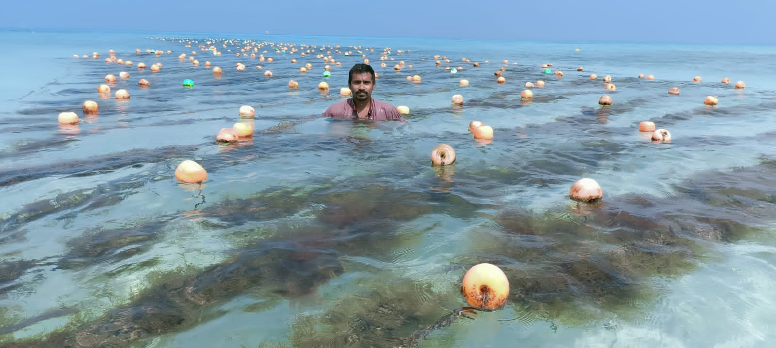

Lakshadweep

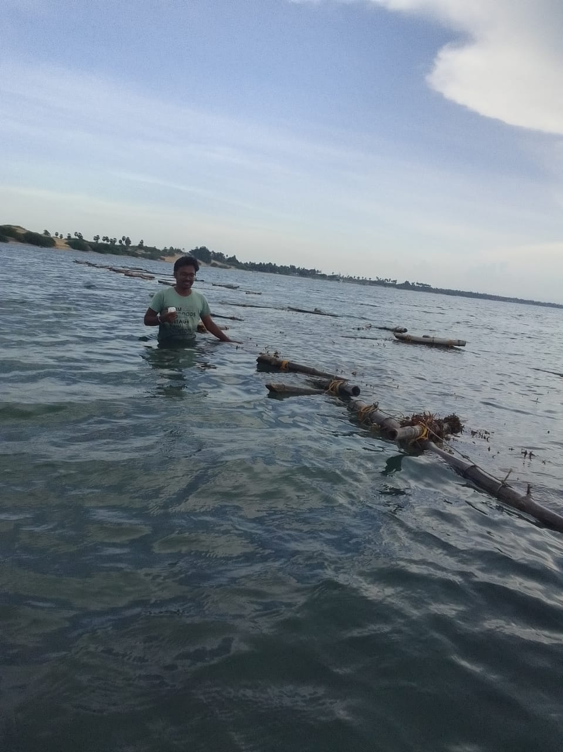

Rameswaram